High sensitivity analysis of nitrogen in carbon materials using temperature-programmed desorption up to 2100 °C
Takeharu Yoshii¹, Ginga Nishikawa¹, and Hirotomo Nishihara^{1,2}
¹ Institute of Multidisciplinary Research for Advanced Materials, Tohoku University, 2-1-1 Katahira, Aoba-ku, Sendai, Miyagi, 980-8577, Japan.
² Advanced Institute for Materials Research (WPI-AIMR), Tohoku University, 2-1-1 Katahira, Aoba-ku, Sendai, Miyagi, 980-8577, Japan.
email for correspondence: takeharu.yoshii.b3@tohoku.ac.jp

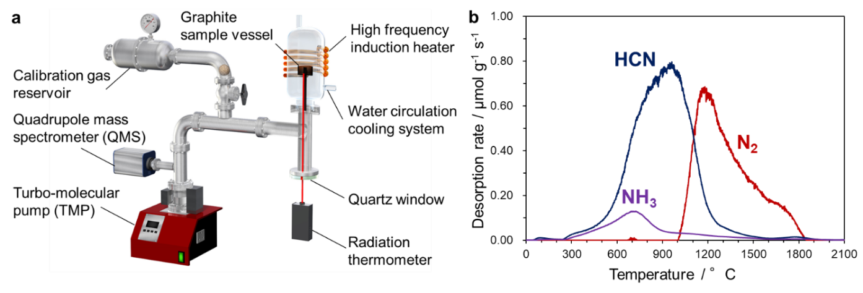
Nitrogen-doped (N-doped) carbon materials are attracting attention in various fields, such as catalysis for oxygen reduction reaction [1]. CHN elemental analysis and XPS were conventionally used for analysis of N species, but their measurement accuracy is about 0.1 wt% [2]. Thus, a technique for detailed qualitative and quantitative analysis of N species is desired. Temperature-programmed desorption (TPD) has been popularly used for the analysis of inorganic catalysts and carbon materials. In conventional TPD, a sample is heated to typically around 1000 °C at a fixed heating rate and the desorbed gases are detected for chemical identification as a function of temperature. However, it has not been developed as a quantitative method for an effective determination of the N species, mainly due to the higher thermal stability of N in carbon materials than oxygen. Herein, we propose high-temperature vacuum TPD up to 2100 °C as a new high-sensitivity analytical method for N-doped carbons (Fig. 1a). In TPD result of N-containing mesoporous carbons, desorption of N-containing gases, NH₃, HCN, and N₂, was observed in a wide temperature range of 300-1900 °C (Fig. 1b). The nitrogen content calculated from the total amount of desorbed gas was 7.9 wt%, which is in close agreement to the CHN analysis (8.0 wt%) and XPS analysis (8.5 wt%). Combined with the results of XPS analysis and DFT calculations, we found that the gas emission patterns of NH₃, HCN, and N₂ obtained by TPD can provide quantitative and qualitative information on the different types of N species including pyrrolic N, pyridinic N, and graphitic N. Furthermore, TPD analysis was performed on a sample with a very small amount of N content and showed a high quantitative accuracy of the order of 10 ppm (0.001 wt%).
Fig. 1 (a) Schematic illustration of the high-temperature vacuum TPD system. (b) TPD profile of the N-containing mesoporous carbon up to 2100 °C for NH₃, HCN, and N₂.
References: 1. J. Nakamura, et. al., Science, 351 (2016) 6271. 2. J. P. Boudou, et. al., Carbon, 44 (2006) 2452.

