**Characterization of Mycelium-Based Leather Using   
Sorption-Ultrasonic Experiments**

Günel Nabiyeva1, Ashoka Karunarathne1, Christopher J. Rasmussen2, Naila Assem2, Jonathan Bauer2, Alexei F. Khalizov3, Gennady Y. Gor1*

1 Dept. of Chemical and Materials Engineering, NJIT, Newark, NJ 07102, USA

2 Bolt Threads Inc., 2261 Market Street Suite 5447, San Francisco, CA 94114, USA

3 Dept. of Chemistry and Environmental Science, NJIT, Newark, NJ 07102, USA  
email for correspondence: [gor@njit.edu](mailto:gor@njit.edu)

Conventional leather is a product that has been used for millennia. Unfortunately, it suffers from a significant carbon footprint due to its livestock source and tanning (the process of converting hides to leather). In addition, there are ethical issues regarding the consumer use of animal-derived products [1,2]. To mitigate these issues, engineering sustainable bio-based leather substitutes has seen increased interest in material science over the past few years. Among the bio-based materials, mycelium, the fungal “root” of a mushroom, is one of the promising alternatives due to its tunable physico-mechanical properties [2].

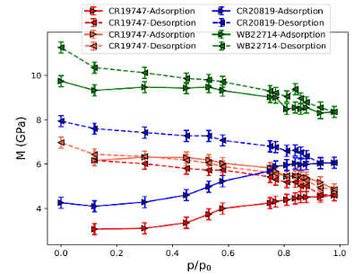

Figure 1: (a) Test samples used for experiments. (b) Longitudinal modulus as a function of relative humidity.

Understanding the effect of humidity on leather material properties is essential to tailoring high-quality leather products. To this end, we employed a novel adsorption-ultrasonic measurement technique [3] to investigate the effects of water sorption on the elastic properties of mycelium-based leather materials. The ultrasonic pulse-transmission method was used to measure the wave speed through the materials while simultaneously measuring their adsorption isotherms. The changes in the measured longitudinal modulus during water sorption and evaporation reveal the behavior of the elasticity of the test materials (Fig 1b). Specifically, the observed irreversible change in the longitudinal modulus during the initial branch of water sorption allows to understand better how the material production process and the presence of additives affect the mechanical properties of this bio-based leather material.

**References:**

1. Ziegler, A. R.; Bajwa, S. G.; Holt, G. A.; McIntyre, G.; Bajwa, D. S. Evaluation of physico-mechanical properties of mycelium reinforced green biocomposites made from cellulosic fibers. Applied engineering in agriculture 2016, 32, 931–938.
2. Fredricks, J. L.; Jimenez, A. M.; Grandgeorge, P.; Meidl, R.; Law, E.; Fan, J.; Roumeli, E. Hierarchical biopolymer-based materials and composites. Journal of Polymer Science 2023, 1–48.
3. Ogbebor, J.; Valenza, J. J.; Ravikovitch, P. I.; Karunarathne, A.; Muraro, G.; Lebedev,M.; Gurevich, B.; Khalizov, A. F.; Gor, G. Y. Ultrasonic Study of Water Adsorbed in Nanoporous Glasses. Phys. Rev. E 108, 2023, 024802.