Brain Tissue Modeled as a Porous Medium with parameters derived from Micro-Iontophoresis Experiments
Charles Nicholson
Dept. Neuroscience and Physiology, New York University School of Medicine, 435 E 30th St., New York, NY 10016, USA
email for correspondence: charles.nicholson@nyu.edu
The cellular structures of the brain are separated by a narrow fluid-filled extracellular (interstitial) space giving brain tissue properties of a porous medium. The porosity and tortuosity can be measured by releasing tetramethylammonium cations from a micropipette and measuring the time-dependent concentration about 100 µm away using an ion-selective microelectrode (ISM), as shown in Fig. 1 [1].
Fitting the results of experiments to an appropriate solution to the diffusion equation [1, 2] revealed that that the typical porosity is φ ~ 0.2 and the tortuosity is τ ~ 1.6, where tortuosity = (D/D*)^{0.5}, D is free diffusivity and D* is effective diffusivity. These results were modeled by regarding the brain as an ensemble of cubic cells of side 2a with cubic voids (expansions of interstitial space) of side b at each corner. Cells were separated by sheets of interstitial space of width 2w and the packed cells formed composite voids of width 2b, as shown in Fig. 2.
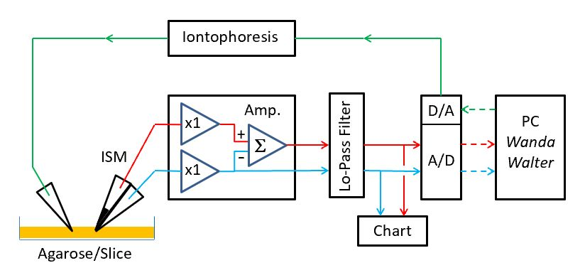
Fig.1. Experimental setup. Diffusion measurements made in agarose (D) or brain slice (D*). Analysis with custom MATLAB software (Wanda and Walter) [1].

Monte Carlo simulations took place in this ensemble using the MCell program [3]. It was found that, to obtain the experimental φ and τ, the required geometry was a = 0.742 µm, b = 0.379 µm and w = 20 nm [4]. The presence of voids was essential to obtain the measured tortuosity and this feature was consistent with freeze-fixed electron microscopy and super-resolution optical imaging [4].
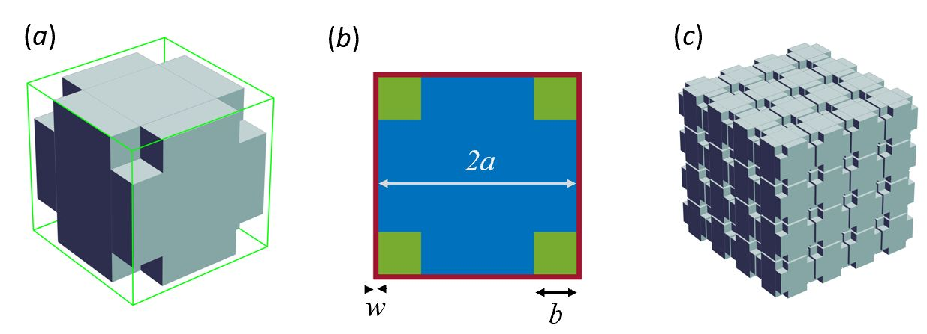
Fig. 2. Model of brain tissue. (a) unit cell with cubic corner voids. (b) top view of cell (c) ensemble of cells spaced 2w apart. In practice, 32³ or 64³ cells used for Monte Carlo simulations [4].
References
1. J. Odackal, R. Colbourn, N. J. Odackal, L. Tao, C. Nicholson, and S. Hrabetova. Real-time iontophoresis with tetramethylammonium to quantify volume fraction and tortuosity of brain extracellular space, JoVE: e55755 (2017).
2. E. Syková, and C. Nicholson. Diffusion in brain extracellular space, Physiological Reviews, 88 (2008) 1277-1340.
3. J.R. Stiles, and T.M. Bartol. 2001. Monte Carlo methods for simulating realistic synaptic microphysiology using MCell. in E. De Schutter, Editor, Computational Neuroscience: Realistic Modeling for Experimentalists, CRC Press: London; 2001, p 87 - 127.
4. C. Nicholson, Sheet and void porous media models for brain interstitial space, Journal Royal Society Interface, 20 (2023): 20230223.

