**Correlations of NMR Relaxometry Data and Polymer Surface Chemistry**

Murilo T. Suekuni1 and Alan M. Allgeier1

1 Dept. of Chem. & Petrol. Eng., University of Kansas, Lawrence, KS 66045 USA  
email for correspondence: alan.allgeier@ku.edu

Nuclear magnetic resonance (NMR) relaxometry enables facile characterization of a variety of porous materials filled with liquids and gases. This study identifies quantitative correlations between surface chemistry and NMR relaxation rates for a series of polymeric particle dispersions, serving as well controlled examples of surface fluid interactions [1].

In NMR relaxometry, the measurement of the rate at which certain nuclei, e.g., 1H, re-equilibrate with an externally applied magnetic field upon radio-frequency excitation provides insight about pore size and pore surface chemistry. A solid-fluid affinity parameter (surface relaxivity, ρ2), linearly regressed from transverse relaxation data, reflects the constrained motion of adsorbate molecules interacting with surfaces. Despite the increasing interest by the characterization community, the role of surface chemistry upon the characterization of wetted surface area and pore volume distribution using solvent relaxometry remains underexplored. D’Agostino et al. have correlated adsorption strength [2] and Schlumberger et al. have correlated water intrusion [3] to relaxation data for silica surfaces. The present study explores wide-ranging polymer particle surface chemistry from hydrophobic polyethylene to hydrophilic polyacrylic acid suspended in water and decane. The observed trends showed a positive relation between heteroatom (oxygen, nitrogen) content and interactions with water, with an opposite behavior for n-decane. This work supports the development of a transverse surface relaxivity database, with values ranging from 0.1 to 8.4 μm s-1 and notable correlations to water contact angles. Ongoing investigation indicates that relaxometry has promising applications in various fields, including heterogeneous catalysis, petroleum reservoir exploration, and drug delivery mechanisms.

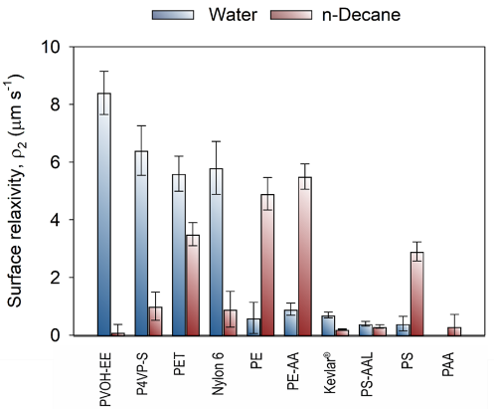

**References:**

1. M.T. Suekuni, A.M. Allgeier. Correlating Surface Chemistry to Surface Relaxivity via TD-NMR Studies of Polymer Particle Suspensions. JACS Au. 3 (2023) 2826-34.  
2. C. D’Agostino et al. Interpretation of NMR Relaxation as a Tool for Characterising the Adsorption Strength of Liquids inside Porous Materials. Chemistry - A European Journal, 20 (2014) 13009–13015.  
3. C. Schlumberger, M. Thommes and coworkers. Characterization of functionalized chromatographic silica materials : Coupling water adsorption and intrusion with NMR-relaxometry . ChemRxiv. Cambridge: Cambridge Open Engage; 2023. <https://10.26434/chemrxiv-2023-jmjs8-v3>