Applications of 3D Amorphous Carbon Molecular Models for Adsorption and Mechanical Property Predictions

Nicholas J. Correntea, Elizabeth L. Hinksa, Aastha Kaseraa, Raleigh Gougha, Peter I. Ravikovitchb, and Alexander V. Neimarka

a Department of Chemical and Biochemical Engineering, Rutgers, The State University of New Jersey,   
Piscataway, New Jersey 08854, United States

b ExxonMobil Technology and Engineering Company, Annandale, NJ, 08801, United States

We explore the capabilities of 3D molecular models of amorphous nanoporous carbons for reproducing the morphological and adsorption properties of practical activated carbons. The 3D models are generated using a reactive forcefield in molecular dynamics (MD) simulations to anneal and quench structures by mimicking the procedures used for production of practical carbons. This approach allows for the formation of corrugated and defective 3D framework built by graphene sheets. The generated structures possess tunable pore size distributions, pore volumes, and surface areas. We characterize these models by Monte Carlo (MC) simulations using standard molecular probes (CO2, N2, and Ar) and show that they replicate the structural properties of practical carbons. We demonstrate how the 3D models quantitatively predict adsorption of simple fluids and alkanes at experimentally relevant conditions. [1, 2] We utilize a hybrid MC/MD simulation scheme to explore how the structures deform in response to fluid adsorption. [2] The suggested method provides a thorough understanding of the effect of pore morphology and flexibility on the adsorption dynamics.

This work is supported by the NSF CBET grant 1834339 and ExxonMobil.

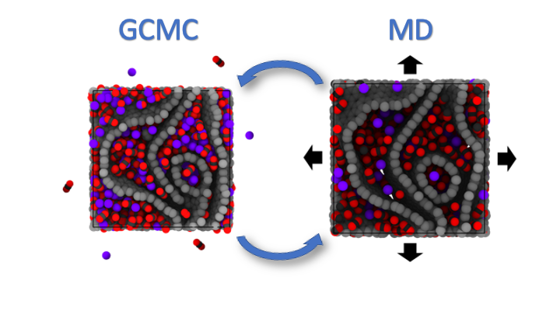

Hybrid MC/MD simulation scheme.

[1] N.J. Corrente, E.L. Hinks, A. Kasera, R. Gough, P.I. Ravikovitch, A.V. Neimark, Modeling adsorption of simple fluids and hydrocarbons on nanoporous carbons, Carbon 197 (2022) 526-533. DOI: 10.1016/j.carbon.2022.06.071

[2] F. Vallejos-Burgos, C. de Tomas, N.J. Corrente, K. Urita, S. Wang, C. Urita, I. Moriguchi, I. Suarez-Martinez, N. Marks, M. Krohn, R. Kukobat, A.V. Neimark, Y. Gogotsi, K. Kaneko, 3D Nanostructure Prediction of Porous Carbons Via Gas Adsorption, Carbon 215 (2023), 118431. DOI: 10.1016/j.carbon.2023.118431

[3] N.J. Corrente, E.L. Hinks, A. Kasera, R. Gough, P.I. Ravikovitch, A.V. Neimark, Adsorption-Induced Deformation of Nanoporous Carbons with Mixtures: A Hybrid MC/MD Approach. In preparation